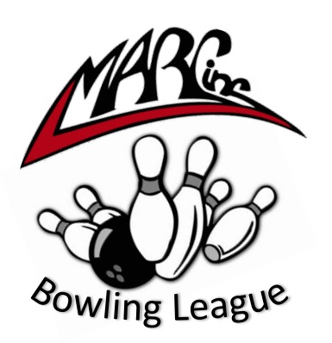2025 2026

SEASON SCHEDULE:

League runs from 2:30p-4:30pm at Spare Time Entertainment in Vernon, CT

Wed. 9/17/25 – Opening Day! Wed. 12/10/25 – Normal Session

Wed. 9/24/25 – Normal Session Wed. 12/17/25 – Normal Session

Wed. 10/1/25 – Normal Session Wed. 1/7/26 – Normal Session

Wed. 10/8/25 – Normal Session Wed. 1/14/26 – Normal Session

Wed. 10/15/25 – Normal Session Wed. 1/21/26 – Normal Session

Wed. 10/22/25 – Normal Session Wed. 1/28/26 – Normal Session

Wed. 10/29/25 – Normal Session Wed. 2/4/26 – Normal Session

Wed. 11/5/25 – Normal Session Wed. 2/11/26 – Normal Session

Wed. 11/12/25 – Normal Session Wed. 2/18/26 – Normal Session

Wed. 11/19/25 – Normal Session Wed. 2/25/26 – Normal Session

Wed. 12/3/25 – Holiday Party Wed. 3/4/26 – Season End Party

There will be NO BOWLING LEAGUE on the following dates:

11/26/25, 12/24/25, 12/31/25

Bowling Banquet Date TBD